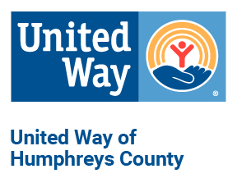
United Way of Humphreys County
Anti-Racism and Ethnic Discrimination Statement

We unequivocally denounce racism/ethnic discrimination, as it undermines the well being and vitality of our communities.
Our United Way network strives to engage culturally diverse community members.
We work with our partner agencies and donors to promote environments to ensure everyone has the resources, support and opportunities they need to thrive.
We commit to using our assets to create more equitable communities.
LIVE UNITED

