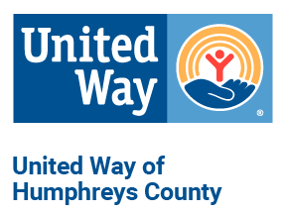
United Way of Humphreys County
Diversity/Equity/Non Discrimination Policy

United Way of Humphreys County (UWHC) is committed to ensuring diversity and equity in all that we do. To that end, our organization will:

- Respect others without regard to race, color, religion, sex (including pregnancy, gender identity and sexual orientation), national origin, age, disability or genetic information.
- Support affirmative action and equal opportunity programs throughout UWHC.
- Refuse to engage in or tolerate any form of discrimination or harassment. UWHC will fight against all forms of discrimination or harassment for the betterment of our community.
- Advocate for diversity and equity within our community whenever possible.
- Make employees and program participants feel valued and respected.
- Seek out board members, employees and volunteers who demonstrate knowledge of and adherence to this policy.
- Investigate any complaint of discrimination or harassment against UWHC or any partner agency.
- Establish a Diversity/Equity Committee of the Board to annually review the Diversity/Equity policy, and to review and work with the Board to address any findings from the investigation of concerns as needed.

