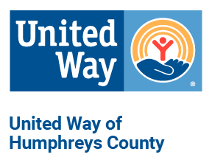
United Way of Humphreys County
Diversity, Equity and Inclusion Statement of Principle

We take the broadest possible view of diversity, by valuing the visible and invisible qualities that make you who you are.
We welcome that every person brings a unique perspective and experience to advance our mission and continue our fight for the health, education and financial stability of every person in every community.
We believe that each United Way of Humphreys County community member, donor, volunteer, advocate and employee must have equal opportunity to solve community problems.
We strive to include diversity, equity and inclusion practices at the center of our daily work.
We commit to using these practices for our business and our communities.
We invite all to join us in embracing diversity, equity and inclusion for every person in every community.
We envision a community where people thrive, live healthy lives, and everyone has the opportunity to reach their full potential.
LIVE UNITED

